**Cross-Sectional Positioning (XSP) Proposal**

**(for assets that are gathered according to travel direction)**

In the analysis of the ‘Side of Road’ field used by the Sign Maintenance Crews, we found that they assign the side of road based on the direction of travel. As a result, the majority of the signs have a side of Road (or XSP) of ‘R’. This is a common way for groups outside of RICS to collect data, as it helps the inventory/maintenance worker identify the location of the asset without having to convert the side of the road when traveling in the decreasing direction.

To address this need, without affecting the XSP of existing TI assets, we came up with the following new XSP values.

|  |  |
| --- | --- |
| XSP | Meaning |
| DTRL | Decreasing Travel Left |
| DTRR | Decreasing Travel Right |
| ITRL | Increasing Travel Left |
| ITRR | Increasing Travel Right |

The benefits of adding these values are:

* Most groups within ODOT are interested in tracking assets based on the direction of travel, not relative to the increasing direction
* We can convert existing assets to this more intuitive method of assigning cross sectional positioning over time
* We can convert to a consistent XSP in reports (a report with a mix of travel XSP and XSP relative to increasing direction can be written to show all assets in either format through a simple conversion.)
* Adding these values would make the interpretation of the data in TransInfo easier for consumers of the data to intuitively understand

The drawbacks of adding these values:

* Not all assets in TransInfo will use the same method of assigning XSP
* It is up to the person recording the data to know if they are traveling in the increasing or decreasing travel direction

For all current assets the XSP (Side of Road) is determined by looking in the Increasing Mileage Direction no matter which way you are traveling.

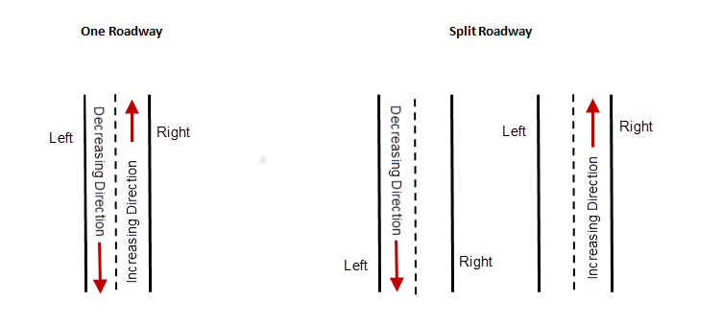

Proposed XSP (Side of Road) to accommodate Sign data needs:

